Fertilizer is any substance or substances which, when added to the soil, help to increase and improve the soils fertility.
Types of fertilizers:
-organic
-inorganic
Organic fertilizers are materials that are allowed to decompose naturally. The role or purpose of organic in the soil is for the improvement of soil structure by separating clay particles because they are close and binding sand particles because they are far apart., it develops the activity of soil organisms as they help to break down the organic materials as well as the addition of plant nutrient to the soil in the form of nitrogen, phosphorus and sulphur.
Types of organic fertilizers
1. Pen or farmyard manures- are obtained from stables and livestock pens. They consist of litter or straw and the solid and liquid excrements of the animals. It is best used when fully rotted.
2. Compost manures- are large quantities of plant and animal waste that is placed in a heap and allowed to decompose to form manure used for garden crops.
3. Liquid manures- are collected from washings of pens and are very rich in nitrogen so that it as to be diluted before use so as not to harm crops.
4. Green manures- Leguminous crops are used as green manure. These crops extract nitrogen from the atmosphere and store them in their root nodules.
Inorganic fertilizers are chemical manures usually obtained from mineral rock or manufactured synthetically. This is where the plant obtain most of their micro-nutrient and macro
-nutrient supplies.
Types of inorganic fertilizers
These are categorized into two simple or straight and compound or complete fertilizer.
Simple/Straight fe.rtilizer contains one of the chief element that the plant needs.
-Nitrogenous – are for leafy crops and plants in their early vegetative growth stage
*sulphate of ammonia
*ammonium nitrate
*calcium nitrate
*urea
-Phosphates – for root development and root crops
*Single superphosphate
*Double superphosphate
*Triple superphosphate
-Potash- for flower and fruit crops as well as for blossom bearing.
*Muriate of potash
*Sulphate of potash
Compound or mixed contain two or three of the chief elements nitrogen, phosphorus and potassium in different proportions/grade or ratios. Grades – of the fertilizer is represented using numbers each number represents one of the chief element from symbols N.P.K hence 5.10.5 or 22.11.11 where the first 5 and 22 is the amount of nitrogen, middle number is the amount of phosphorus and the last 5 and 11 is for the amount of potassium. The ratio of the fertilizer is calculated by dividing the smallest number in the grade through all the numbers. E.g. 5.10.5 smallest number is 5 divide through all the numbers will give the ratio 1.2.1
Examples of compound or mixed fertilizers
N.P.K
13:13:21
10:10:10

How does the types of fertilizers assist with maintaining fertility?
If you remember in the previous lesson on plant nutrients; plants uses 17 nutrients to carry out their processes and as such fertilizer are a source for 14 of those. Hence, the reason for ensuring that the soil has the required amount of nutrients to sustain the plant while it is there to produce food for man and animals.
Activities
1. A farmer has the following five types of fertilizer in his storeroom
10:10:10
20:05:05
15:15:20
10:20:05
05:05:20
Which one is best for application to the following crops on land of average fertility?
Crop Fertilizer
1. Young tomato seedlings
2. Flowering sweet potatoes
3. Lettuce three weeks old
4. Sweet pepper that starts to bear
5. Cucumber that requires a balance amount of fertilizer

Fertilizer bag- Fertilizer bag, the brand name of the company, Name of fertilizer, grade and/or ratio, address of the manufacturer and the weight of the fertilizer see diagram below and use the information to label the parts.
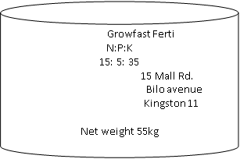
Methods of applying fertilizers
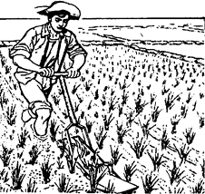
Row placement

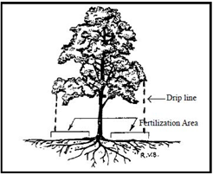Band application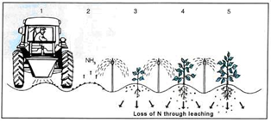Foliar application
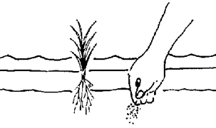Side dressing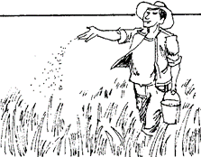Broadcasting
Activity: Describe each method named above.
The type of fertilizer applied is dependent upon the crop one grows and the stage of growth, the availability of nutrients in the soil and the weather conditions. From a soil analysis the one can find out which elements are lacking in the soil. Then fertilizer is applied base on the nutrient requirement of the crop that is grown and the stage of development. The weather must be taken into consideration when fertilizers are to be applied. Some fertilizers, like nitrate are easily dissolved and are readily leached out of the soil. Under wet conditions such fertilizers should be applied in small quantities at closer periods of time. The amount of fertilizer that is applied to the soil is also important. Too little will cause the plant to show deficiency symptoms in the vegetative areas. Whilst too much will cause the root of plant to become concentrated leading to diffusion of the cell sap out of the cells into the soil. The plant will then become dehydrated or plasmolysed causing it to callapse and die.
Activity: Discuss how fertilizers ought to be stored

