ST. CATHERINE HIGH SCHOOL SUBJECT: FOOD NUTRITION AND HEALTH
TOPIC: FRUITS

INSTRUCTIONS TO STUDENTS:
With use of prescribed text(s) and other available resources
read and complete the worksheet.

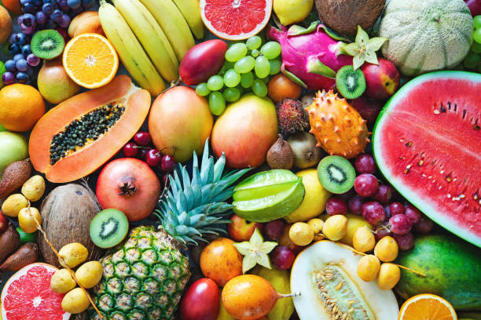

Fruits are considered to be a food group unique for the following reasons:
- Diversity in flavors
- Diversity in textures
- Abundance of colours
- Wide variety of types /species
- Fruits carry seeds that are planted or scattered to enable new growth.
Fruits have become increasingly available because of modern transport avenues, import and export arrangements and preservation techniques.

PREPARATION OF FRUITS
Most fruits may be consumed raw, especially when ripe, but they may be cooked:
- Identify the best method(s) that may be used if fruit is to be cooked
………………………………………………………………………………………………………………................................................................................................................................................
- Discuss briefly the guidelines to be considered when cooking fruit especially to conserve nutrients.
……………………………………………………………………………………………………………….………….…………………………………………………………………………………………….

Points to observe when choosing Fruits:
- Choose unbruised, unblemished fruit
- Avoid fruit with mould even if it is cheaper
- Wash to remove dust from harvesting and chemicals from spraying
- After choosing, travel with them carefully to avoid damage

CATEGORIES OF FRUIT WITH APPROPRIATE EXAMPLES

Taken from Food and Nutrition for CSEC (Anita Tull and Antonia Coward)

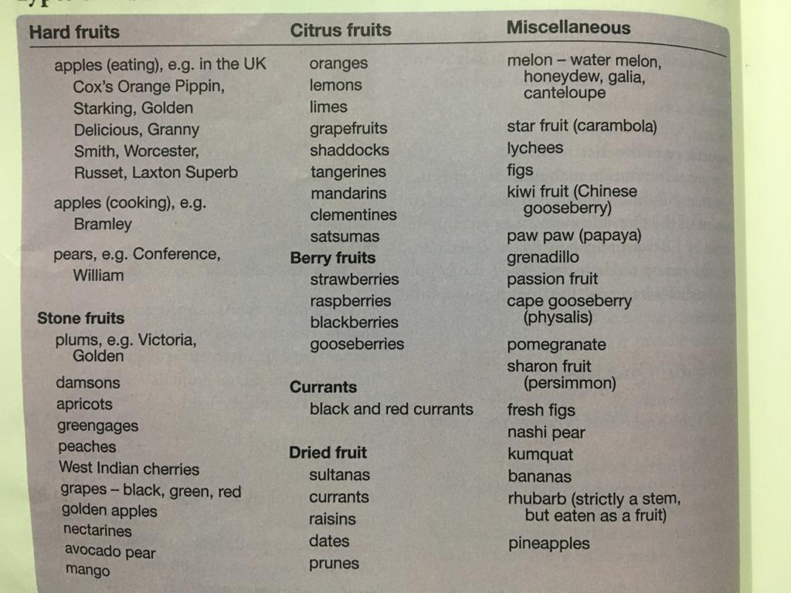

DIETARY VALUE OF FRUITS

Fruits are often called welfare foods or "glow foods"

Fruits are rich in Vitamin C

Name fruits that are rich or good sources of Vitamin C:
…………………………………………………………………………………………………………………………………………………..…………………………………………………………………….
Name fruits that are reasonable sources of Vitamin A:
……………………………………………………………………………………………………………………………………………………………………………………………………….. ……………....

Carbohydrate:

Starch is produced in fruit during the process of…………………………………...………………
As fruits become ripe the starch is converted to…………………………………making the fruit sweeter.
Fruits are high in NSP (Non Starchy Polysaccharide otherwise called ………………………………………………..
Pectin found in under ripe fruits helps jams to set and remove waste from the body.

Minerals:

Name the few fruits that supply the body with Iron and Calcium:
……………………………………………………………………………………………………..…….
NB. Fruits contain a small amount of Vitamin B and NO Vitamin D.

STORING FRUITS
Fresh fruits should be stored in cool, ventilated conditions. Discuss other guidelines for the proper storage of fruits:
…………………………………………………………………………………………………………………………………………………………………………………………………………………………
Demonstrate your creativity in food selection and meal planning by skillfully using fruit in the following categories.

APPETIZERS | MAIN MEAL ITEMS | DESSERTS | ACCOMPANIMENT | BEVERAGES
Fruit Soups | Grilled Shrimp and Pineapple | Fruit Bowl | Apple Swans | Citrus Cooler
Main Source: Food and Nutrition for CSEC (Anita Tull and Antonia Coward)

