Physical Education and Sports

Lesson for today ( March 23, 2020)

The circulatory system
The circulatory system is a network consisting of blood, blood vessels, and the heart. This network supplies tissues in the body with oxygen and other nutrients, transports hormones, and removes unnecessary waste products.

The heart
The heart is made of specialized cardiac muscle tissue that allows it to act as a pump within the circulatory system.
The human heart is divided into four chambers. There are one atrium and one ventricle on each side of the heart. The atria receive blood and the ventricles pump blood.
The human circulatory system consists of several circuits:
- The pulmonary circuit provides blood flow between the heart and lungs.
- The systemic circuit allows blood to flow to and from the rest of the body.
- The coronary circuit strictly provides blood to the heart (not pictured in the figure below).
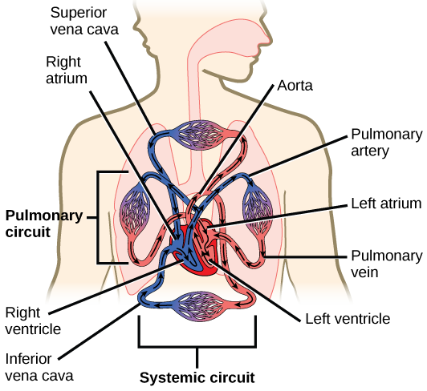
Diagram showing the flow of blood from the heart to the rest of the human body.

Blood and blood vessels
Blood from the heart is pumped throughout the body using blood vessels. Arteries carry blood away from the heart and into capillaries, providing oxygen (and other nutrients) to tissue and cells. Once oxygen is removed, the blood travels back to the lungs, where it is re-oxygenated and returned by veins to the heart.
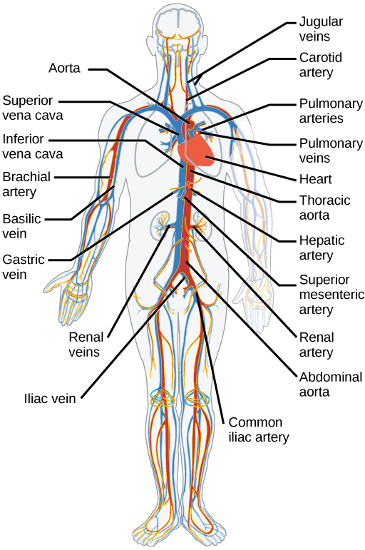
Diagram labeling the major arteries (red) and veins (blue) in the human body
The main artery of the systemic circuit is the aorta which branches out into other arteries, carrying blood to different parts of the body.

Common mistakes and misconceptions
- Arteries usually carry oxygenated blood and veins usually carry deoxygenated blood. This is true most of the time. However, the pulmonary arteries and veins are an exception to this rule. Pulmonary veins carry oxygenated blood towards the heart and the pulmonary arteries carry deoxygenated blood away from the heart.
- Blood is always red. Veins can appear blue as we see them through our skin, leading some people to believe that deoxygenated blood is blue. However, this is not the case! Blood only appears blue because of the way tissues absorb light and our eyes see color. Although oxygen does have an effect on the brightness of the blood (more oxygen makes a brighter red, less makes it darker), blood is never actually blue.

Questions
  - How many atrium and ventricle makes up the heart?
  - What makes up the circulatory system?
  - State the function of the pulmonary and the systematic circuit in the circulatory system?
  - How is blood circulated by the blood vessel?s

