Information Technology Grade 10
Topic: COMPUTER NETWORKS AND WEB TECHNOLOGIES
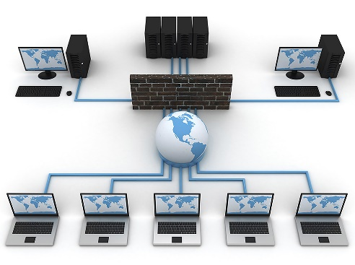
Sub Topic: Computer Networks and Web Technologies

A network is group of two or more computers linked together so that they can share resources (hardware, software and data) and can communicate with one another.
Read pages 97-100 of your textbook

Types of networks
1. Local area network (LAN)
LANs consists of a collection of microcomputers, such as in an office building, department or school that can share peripherals, files and programs and communicate with each other on the network. Each microcomputer that forms part of the network is connected either by cables or by a wireless link.
Benefits of a LAN are:
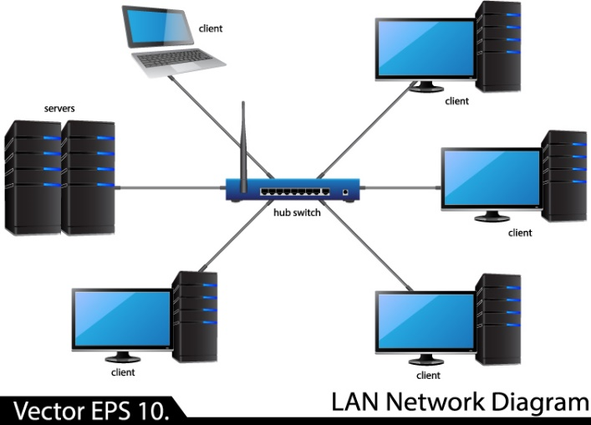
- Hardware such as printers can be shared.
- Storage facilities can be shared.
- Software and data files can be shared by many users.
- It is usually cheaper to buy one copy of a software application and pay license fee for several machines, than to buy individual packages for each computer.
- Users can work together on a single document.
- User can communicate using e-mail.

Disadvantages of a LAN are:
- The initial set costs are high
- There is increased risk of data corruption. Since many users will be using the system, there is greater chance of data being corrupted or tampered with.
- There is a greater risk from viruses because they easily spread between the computers that are part of the LAN.
- If the file server fails, all workstations are affected and or work stored on shared hard disk drives will not be accessible; nor will it be possible to use networked printers, etc.
- Networks can be complicated to maintain and may require a network manager. Additional costs may therefore be incurred.

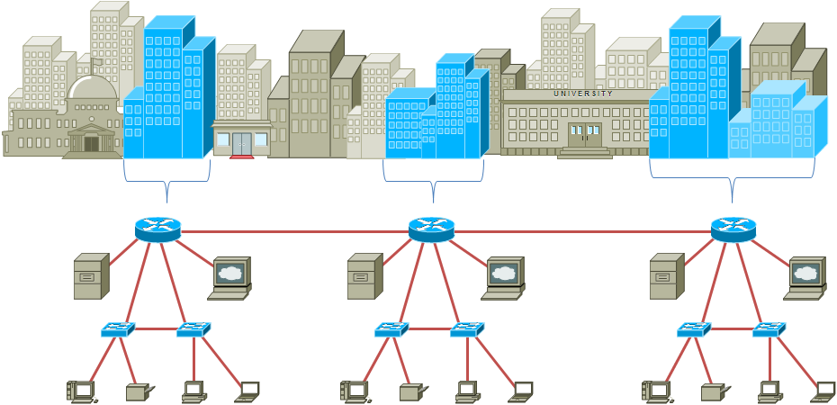
2. Metropolitan area network (MAN)
This network connects LANs in a metropolitan area such as a city, state or town. It includes one or more LANs but covers a smaller geographical area than a WAN. It is usually managed by a single network provider that sells the service to users. Telephone companies and cable television operators provide connections to the MAN.

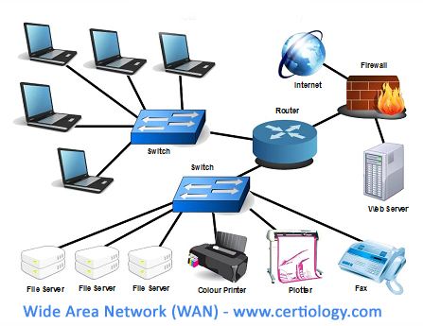
3. Wide area network (WAN)
- This network connects mainframes, LANs and PCs across a large geographical area such as a city, a country or the world using a combination of many types of media such a telephone lines, cables microwave links, satellite links. WANs are used mainly by universities, research centres and large organizations with branches in different countries.

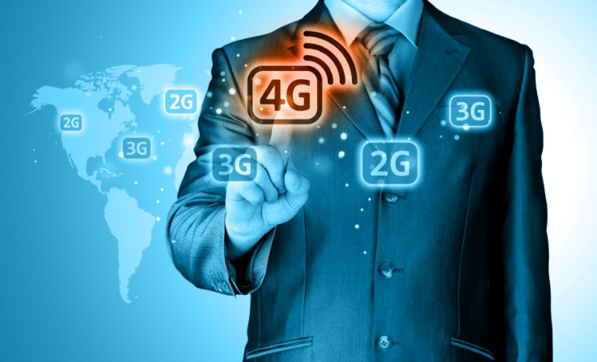
4. Mobile network
Mobile networks are also known as cellular networks. They're made up of "cells," which are areas of land that are typically hexagonal, have at least one transceiver cell tower within their area, and use various radio frequencies. These cells connect to one another and to telephone switches or exchanges. Cell towers connect to each other to hand off packets of signals — data, voice, and text messaging — ultimately bringing these signals to mobile devices such as phones and tablets that act as receivers.
Providers use each others' towers in many areas, creating a complex web that offers the widest possible network coverage to subscribers.
Mobile networks have become the backbone of telecommunications, with the widespread adoption of smartphones, tablets, and other mobile devices.
(a) Concept of mobile network as radio based common carrier - means an entity that provides communications services primarily by use of radio or other wireless means.
(b) Overview of mobile networks: from 2G to current.

Generation | Features | Problem | Examples
2G | Text messaging, multimedia messaging, caller ID and the SIM card | Phone calls dropping and slow data transmission rates | 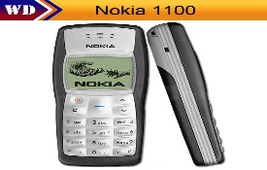
3G | All of 2G, plus web browsing, email, video downloading, picture sharing and other smartphone | Major limitations of the 3G network is network coverage | 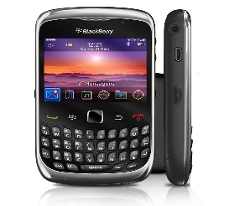
4G-LTE  (Long Term Evolution) | All of 3G plus significantly faster speeds and increased network coverage | Still problems with network coverage | 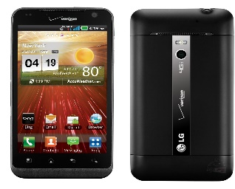

Wireless network technologies (for example, Bluetooth, Wi-Fi, hotspot).
- Hot spot is a wireless network that provides Internet connections to mobile computers and other devices. They are used by mobile users to check e-mail, browse the Web and access any service on the Internet. (a hotspot is a public place where you can access Wi-Fi)
- Bluetooth is a standard developed by electronic manufacturers that allow any sort of electronic equipment (computers, digital video cameras, cell phones, PDAs, etc to automatically make their connections without wires, cables or any direct action from a user. One disadvantage of Bluetooth is it cannot transmit signals through walls and distances of over 3 meters.
- Wi-Fi is short for wireless fidelity. It is a type of broadband Internet connection that uses radio signals to provide Internet connection to wireless computers and devices.

Level of privacy (intranet, extranet, Internet).
Internet
- This is the world’s largest WAN. It is a network of networks that connects computers worldwide via a huge set of telecommunication links. The Internet does not have a central authority. No one is in charge of the Internet. There are organizations which develop technical aspects of the network and set standards for creating applications on it, but no one governing body or government is in control.

Advantages of the Internet
- Vast volumes of information are available on virtually any topic.
- Information can be updated regularly.
- Much of the information is free.
- It allows people to telecommute i.e. work from home using Internet facilities like e-mail, and keep in touch cheaply and quickly with friends and relatives.
- It is convenient for many common chores e.g. booking flights and Internet banking.
- It is easily accessible: all you need is a PC with modem and a phone line.

Disadvantages of the Internet
- Lots of incorrect information is available; there is no authority to check the accuracy of Internet documents, etc.
- It can be difficult to find exactly what you need because of the large volume of information available.
- Computer viruses can easily be downloaded without the user realizing.
- There are lots of undesirable websites on the Internet (pornography, racist, propaganda (half truths), etc.).
- The security of computers and WAN/LAN systems connected to the Internet may be at risk from hackers.

For a basic connection to the Internet you need the following:
- Computer hardware – a personal computer and modem
- Communication link – a phone line or cable or satellite dish
- An Internet Service Provider (ISP)
- Computer software – facility to implement TCP/IP and an Internet browser

Intranet
- This network is a micro-version of the Internet within a company or organization. It offers the same features of the global Internet but limited to a small area such as a factory site or an office.
- Authorized users within the company can use the company’s intranet to find information easily and quickly. The documents in the intranet have links to other documents in the network or outside the wider Internet. This network uses browsers and software just like those used on the Internet.
- Examples:
A school may have an intranet so that students and teachers and office staff and administrative staff can work and share files and peripherals within the school environment. Once they are not logged in at school, they cannot access the intranet.
- A company's employees can access the company's intranet to do their work, share files and peripherals. If you are not an employee, then no access!

Extranet
- This is an Intranet that allows limited access to it by people outside the company. A company may set up an extranet, for example, to provide technical support information to its customers based on products it sells or services it provides.
- For example: Suppliers can have specifed access to the company's network. That is, they can only access the system that may tell them about their supplies to that company. They cannot however, access other areas on the network.
- Customers can have limited and restricted access to a company's network to say, place orders online or check the status of their order.

Subtopic: Transmission Media
Objective: Explain the functions of the basic components of a network; Basic components and functions: (a) Transmission media: (i) Wired: twisted pair, coaxial, fibre; and, (ii) Wireless: infrared, microwave, satellite.

Transmission media
These are the ways and/or materials used to move data. Media can be cabled/wired or wireless.
Watch: https://youtu.be/Mlnl4UpD3Lg

Cabled/wired media
- Twisted pair cable: A Twisted Pair is a pair of copper wires, with diameters of 0.4-0.8 mm, twisted together and wrapped with a plastic coating. There are two types of twisted pair, unshielded and shielded twisted pair. It is used for home networking where there is no great need for speed. It is a cheap convenient method of connecting computers and peripherals in a network.
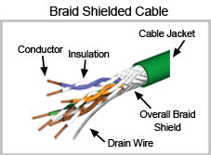

- Coaxial cable: Coaxial cable is a two-conductor cable in which one conductor forms an electromagnetic shield around the other. The two conductors are separated by insulation. It is used in medium-sized networks to transmit voice, video and data at moderate speeds. This is more expensive than twisted pair because the transmission capabilities are higher.

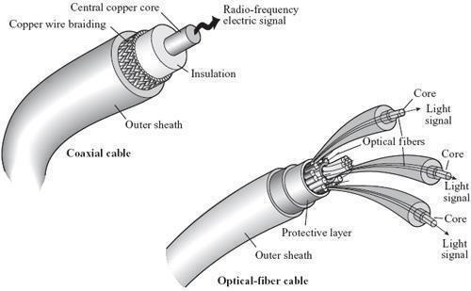

- Fibre optic cable: Optical fiber consists of thin glass fibers that can carry information at frequencies in the visible light spectrum and beyond. The typical optical fiber consists of a very narrow strand of glass called the core. Around the core is a concentric layer of glass called the cladding. It is used to transmit large volumes of digital data at extremely high speed virtually error-free. These are relatively expensive.
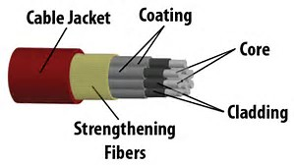
Wireless Transmission Media
Wireless transmission media refers to a form of unguided media that does not require the establishment of physical links between two or more devices. Wireless transmission is used when installing cables or using wired transmission would be impossible, impractical or inconvenient.
Wireless media include communications satellite, microwave links, infrared. Wireless network technology also called hot spot technologies refers to Bluetooth and Wi-Fi. All of these are used to provide broadband. Despite their numerous advantages over wired communication media, wireless media is more prone to security threats, hacking and have a high initial setup cost.

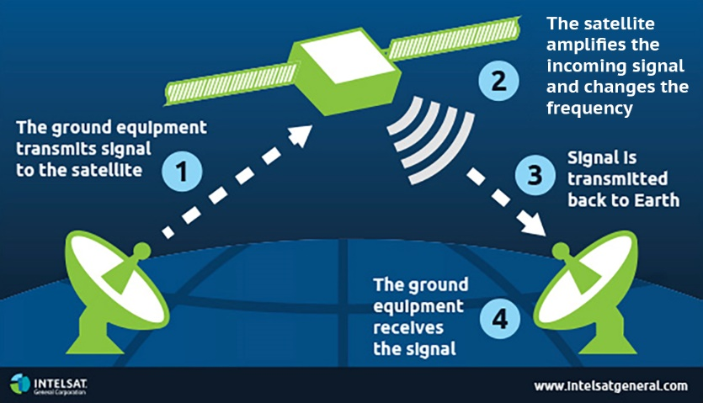
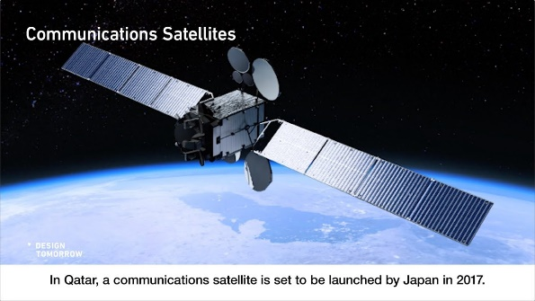
Communications satellite is a space station that receives microwave signals from an earth-based station, amplifies (strengthens) the signals, and broadcasts the signals back over a wide area to any number of earth-based stations.

Microwaves are radio waves that provide a high speed signal transmission. It is also called fixed wireless and involves sending signals from one microwave station to another. A microwave station is an earth-based reflective dish that contains the antenna, transceivers and other equipment necessary for microwave communications.
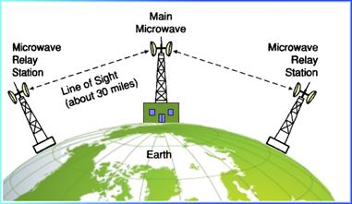
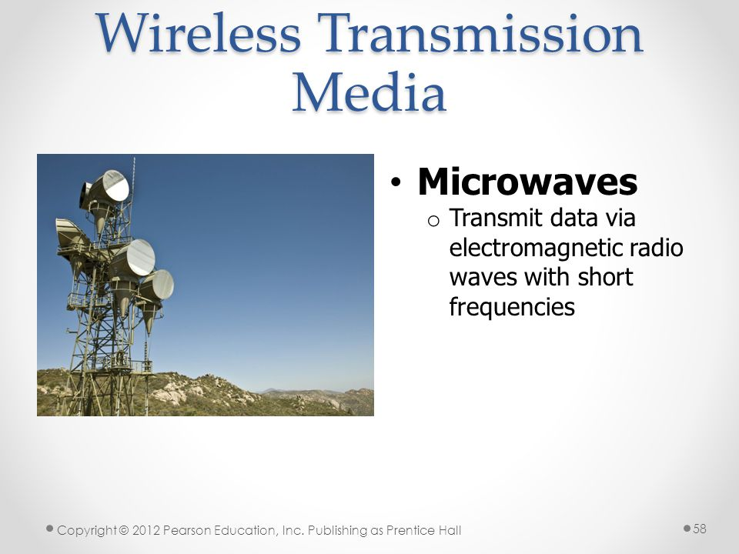

Infrared is a wireless transmission medium that sends signals using infrared light waves. Mobile computers and devices , such as mouse, printer, and smart phones often have IrDa (Infrared Data Association, a group of device manufacturers that developed a standard for transmitting data via infrared light waves) ports that enables the transfer of data from one device to another using infrared light waves.

Switch, router, modem
From a physical perspective, a modem, router, and switch all look very similar. However, there are key differences between them internally, and each are used for different purposes on a network.

What Is a Modem?
A modem is often provided by your ISP (Internet Service Provider) which enables a network access to the internet. In some cases ISPs provide “hybrid” modem/router combination, this device might be power efficient to some extent, it actually limits your network potentials. So suggestion is to request a standalone modem whenever possible to increase the available resources on the network.

What Is a Router?
When connecting more than one device to a modem, a router is generally required. A router acts as the “traffic director” of a network. It takes information provided by the modem and routes it to the devices attached to the modem, then the router creates Network Address Translated ( NAT) internal private IP address to the connected devices so they can be accessed. Devices like computers, game consoles and etc can be connected to a router wirelessly or through network cables. Some advanced features of a router includes built-in firewall to help protect the network from unwanted traffic.

What Is a Switch in Networking?
A switch (such as a 10GbE switch or Gigabit PoE switch) is used to provide additional ports, expanding the capability of the router. A network switch learns the association between the MAC addresses of connected devices and its switched ports. A switch only sends data to where it needs to go, thus reducing the amount of data on the network, thereby increasing the overall performance of the connected devices while improving security. Often connected to a router, a switch will not provide routing capability and should not be connected directly to the modem unless a DHCP (Dynamic Host Configuration Protocol) server is present elsewhere on the network. A DHCP server is used to issue unique IP addresses and automatically configure other network information. In most homes and small businesses, the router acts as the DHCP server. In large networks, a single computer might act as the DHCP server.
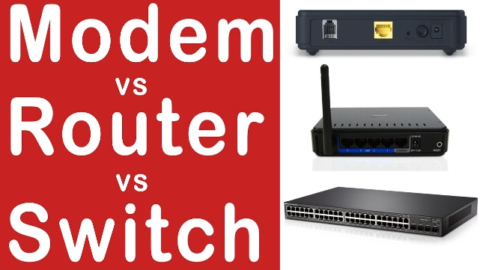
Watch: https://youtu.be/Mad4kQ5835Y
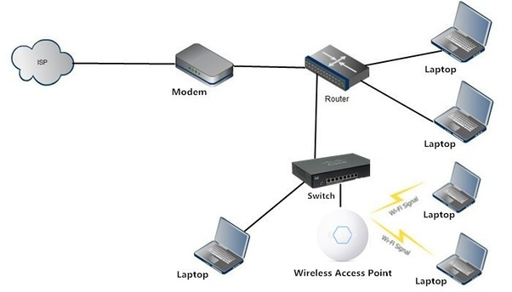

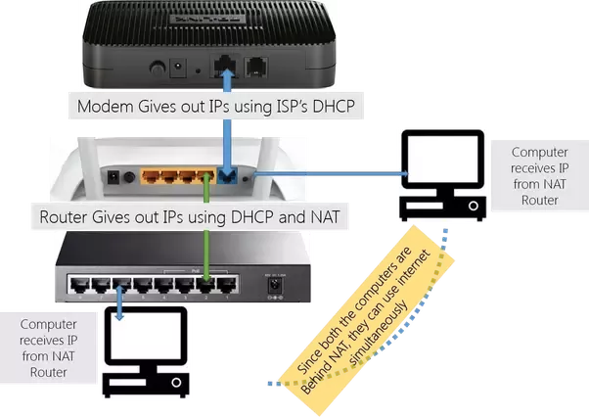

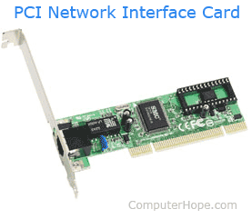
Network interface card/network adapter.
Short for network interface card, the NIC is also referred to as an Ethernet card and network adapter. It is an expansion card that enables a computer to connect to a network; such as a home network, or the Internet using an Ethernet cable with an RJ-45 connector.
Due to the popularity and low cost of the Ethernet standard, nearly all new computers have a network interface build directly into the motherboard. Wireless NIC are found in laptop computer.

Objective 2: Assess the importance of mobile communication technologies as a component of modern communication networks; Suitability of mobile networks to various applications (for example, education, commerce, and journalism).
[Pros and cons of mobile technology in the fields of education, commerce, and journalism]

- Mobile communication and connectivity have been changing the way business communicators create, plan and distribute messages. It allows for better marketing strategies.
- Pro: Mobile technology allows for one to keep in contact with other as its portable and allow them to feel safe as they go from one place to another as you can be in constant dialogue with family. Con: there is the concern of privacy and safety, on the internet you can be anonymous and therefore any individual can be communicating with you.

Education
Pro
- Computers and the internet have made it easier for students to access academic material at any given moment of the day. Nowadays students spend more time surfing and doing research online than they watch television.
- Using technology in the classroom allows you to experiment more in pedagogy and get instant feedback.
- Technology allows for more active learning; you can increase engagement through online polling or asking quiz questions during lectures (with instantaneous results).
- There are countless resources for enhancing education and making learning more fun and effective
- With technology in the classroom, your students have instant access to fresh information that can supplement their learning experience
Con
- Despite its abundance a lot of the information published online is inaccurate. Since most publishers do this for money, they write about anything to get massive traffic from search engines to generate more money. A publisher will have a list of keywords most searched for online, and they will write what they know, no one will review this data, but a student will use this information thinking its all bulletproof. Most students have been penalized in some form because they use this type of data from the internet.
- Technology in the classroom can be a distraction.
- Technology can disconnect students from social interactions
- Technology can foster cheating in class and on assignments
- Students don’t have equal access to technological resources

Commerce
- Time is money. Now there’s no need for customers to go to a physical store to make a choice and purchase the item they need. Mobile commerce allows customers to save time and money. It is similar to the eCommerce advantage with one little difference: they can do it ON THE GO!
- Mobile payments. Customers can pay for their purchases right there in the app with “in-app payments.” It means that payments are hosted by the platform and don’t require third-party services. Another good thing is the existence of mobile wallet where customers can register a pre-paid account from where money can be debited with each purchase.
- Accessibility. Users are not obligated to carry a modem around with them to have an internet connection. A network signal is enough for a user to run the app and perform transactions. Conclusion: it’s a huge range where you can reach the customer.
- Instant contact. This one is great for retailers if done and controlled properly. Nowadays, it’s beyond easy for customers to reach businesses and solve problems concerning purchases: calling with one click, live chats inside the app, 24-hour billing & sales, etc.
- Customization. Your business’ mobile app can give priceless data about every user’s action. With this information you can offer your customers amazing experiences by actively suggesting products according to their needs. It is a win-win for both sides.

MCOMMERCE DISADVANTAGES
- Sense of security. Nowadays people have less trust in the security of entering payment information on a smartphone, compared to desktop or a laptop
- Smartphones’ small screen size. This leads to the problems with viewing products and reading information, especially if the website is not mobile optimized. But most web apps are also inconvenient to use if the retail company has a wide range of products. But this problem goes away with a properly made mobile app.
- Inconvenient to make big purchases. Often when you have to compare many options or do research before buying car, house, boat. In these situations, a desktop is more convenient to use.

Journalism
Mobile journalism describes journalism that is committed to using mobile platforms such as smart phones and tablets. Potential applications with mobile journalism are: covering protests, live tweeting a city council meeting, covering a perp walk of an accused criminal, and quickly going out and getting feedback for a product.
Pros: Mobile journalism allows journalists to be flexible. This form of journalism also allows journalists to move information in a variety of fashions. It costs less to have because the journalist won’t have to carry around large, specialty equipment everywhere they go.
Cons: There are also cons that come with mobile journalism. The transmission of information is limited by infrastructure. The technology hasn’t necessarily caught up to people’s desires. There have also been problems with quality and the apps work until they don’t.

Objective 3: explain the interrelationship among key Web technology concepts.
- World Wide Web: The World Wide Web (WWW) is combination of all resources and users on the Internet that are using the Hypertext Transfer Protocol (HTTP). A broader definition comes from the World Wide Web Consortium (W3C): "The World Wide Web is the universe of network-accessible information, an embodiment of human knowledge. "the Web is a communications model that, through HTTP, enables the exchange of information over the internet.
- Hypertext Markup Language: HTML (Hypertext Markup Language) is a text-based approach to describing how content contained within an HTML file is structured. This markup tells a web browser how to display the text, images and other forms of multimedia on a webpage.

- Hypertext Transfer Protocol: HTTP (Hypertext Transfer Protocol) is the set of rules for transferring files (text, graphic images, sound, video, and other multimedia files) on the World Wide Web. As soon as a Web user opens their Web browser, the user is indirectly making use of HTTP. HTTP is an application protocol that runs on top of the TCP/IP (Transmission Control Protocol/Internet Protocol) suite of protocols (the foundation protocols for the Internet).

- Hyperlinks: On the Web or other hypertext systems, hyperlink is a synonym for both link and hypertext link. a link from a hypertext file or document to another location or file, typically activated by clicking on a highlighted word or image on the screen.

- Web Server: A web server is a computer that runs websites. It's a computer program that distributes web pages as they are requisitioned. The basic objective of the web server is to store, process and deliver web pages to the users. This intercommunication is done using Hypertext Transfer Protocol (HTTP).

- Web Page: A Web page is a representation of a document that is actually located at a remote site. It is a document that can be accessed through the internet The information on a Web page is displayed online with the help of a Web browser such as Internet Explorer, Mozilla Firefox or Google Chrome. The Web browser is connected to the Web server, where the website’s contents are hosted through HTTP.

- File Transfer Protocol: FTP stands for File Transfer Protocol. A protocol is a system of rules that networked computers use to communicate with one another. FTP is a client-server protocol that may be used to transfer files between computers on the internet. The client asks for the files and the server provides them.

- Web Browser: A web browser is a software program that allows a user to locate, access, and display web pages. In common usage, a web browser is usually shortened to "browser."

- Uniform Resource Locator: A URL (Uniform Resource Locator) is naming for addressing documents accessible over the Internet. An example of a URL is https://www.computerhope.com/, which is the URL for the Computer Hope website.

- Upload and download: Upload– is the sending of data from a computer to the internet. Download– is the receiving of file (copying of data) from the internet to a computer.

- Email: messages distributed by electronic means from one computer user to one or more recipients via a network.

See question sheets document
Reference
- http://www.cables-solutions.com/switch-vs-router-vs-modem-difference.html
- https://www.lifewire.com/what-is-dhcp-2625848
- http://ecomputernotes.com/computernetworkingnotes/communication-networks/describe-the-different-transmission-media
- https://www.computerhope.com/jargon/n/nic.htm
- https://www.useoftechnology.com/pros-cons-technology/
- https://tophat.com/blog/6-pros-cons-technology-classroom/
- https://www.quora.com/What-are-the-pros-and-cons-of-mobile-commerce/answer/Oksana-Kovalchuk-6
- https://ggibit.wordpress.com/2015/11/04/pros-and-cons-of-mobile-journalism/
- https://searchwindevelopment.techtarget.com/definition/HTTP
- Gay, G. and Blades, R. (2019). Information technology for csec. (3rd ed).United Kingdom: Oxford University Press

Next Topic: concepts of computer security, cybersecurity and computer misuse;

