Day 1
An application for employment may assume three forms:
- A formal letter composed by the applicant in which details of name, age, qualification and experience are given.
- A curriculum vitae with an introductory letter of application
- The completion of a form provided by the employer, in which the required information is supplied under various headings.

Tips to fill out an application form
- Consider photocopying the form before you begin so you have a spare copy in case of a mistake.
- Some companies now offer the application online either to complete through their website and submit, or download and print off or e-mail
- Always read the form through at least once before you complete any part of it. Your house number may go in a separate box to the street name, for example. Making little mistakes like this looks sloppy and unprofessional.
- Before you start writing, gather together all the relevant information you will need, for example previous addresses, examination certificates, passport or social security details.
- Note special instructions such as “USE BLOCK CAPTITALS’, ‘Complete in black ink’ ‘Use first hand’ (this means hand write – do not type) or ‘Do not write outside boxes’. Always follow these instructions.
- Draft any long paragraphs such as personal statements on scrap paper and finalize them before transferring them to the final form.
- Use pencil lines that can be rubbed out to help you write in straight lines- or make a line guide to sit behind the page that shows through the paper.
- Take your time and make sure you are free from distractions you can concentrate.
- Use your best handwriting –prospective employers won’t waste time trying to decipher an illegible form.

Day 2
The format of the letter of application for employment should contain the following elements:

- The address of the sender and the date.
- The name and address of the recipient
- The greeting or salutation
- The body of the letter
- The complimentary close

Guidelines for writing a letter of application.
- Say which job you are applying for.
- Summarize qualifications or examinations taken.
- Personal interest help build a picture of the kind of person you are.
- State relevant past experience and why you think you are suitable.
- Say what you hope will take place next and refer to sources of reference.
- Print your name under your signature as signatures can sometimes be difficult to read.

Day 3

The résumé
- Keep the résumé to ONE page in length
- Choose a style of organization that is logical and clear to read.
- Write in a simple and direct style.
- Avoid using “I” even though you are writing about yourself.
- Write in short phrases when detailing experience instead of long sentences.
- Write active statements that show results. For example, do not write I was the president of the Film Club, instead say President of the Film Club- responsible for organizing films and collecting monies.
- Include all the relevant information-and address anything specific the advert has requested.
- Write neatly and check the accuracy of your spelling and grammar.

The different types of résumé
Chronological résumé

Name
Address
Telephone number(s)
E-mail address
Objective
Experience
Education
Technical Skills

Functional résumé
Name
Address
Telephone number(s)
E-mail address
Objective
Skills and capabilities
Experience
Education
Employment History

A cover letter to accompany the resume is attached. This letter provides an introductory statement which refers to the job advertisement and mentions any attachments to the application.

Day 1: Examine the form below ( if you do not have access to printing write the information in your books) and fill in the relevant information.
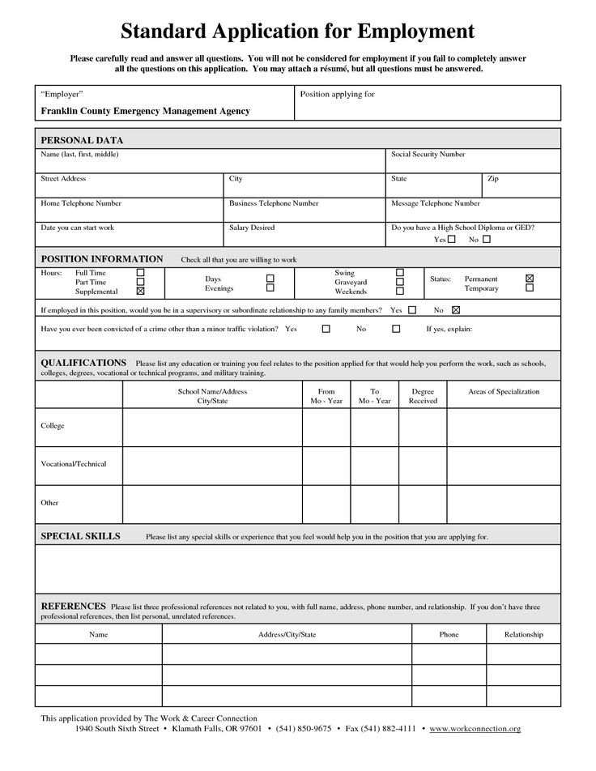

Day 2

Consider that Burger King needs students to work in the summer as cashiers. Write a letter of application.

Day 3

Consider that you have completed your CSEC examinations. You have seen an advertisement in The Sunday Gleaner for sales clerk for a clothing store. Write a cover letter and a résumé applying for the job.

