Product Design and Development

What is design?

A design can be define as a plan or a drawing produced to show the look, functions and workings of a building, garment, gadgets and tool before it is made.

What are products?
A Produce can be define as the making or manufacturing of components or raw materials.

Steps involve in making a product.

There are many steps involved in making a produce from just a concept in your mind to reality. Before the product is conceptualize we first have to go through what is known as product design development.
- Product concept: This is where you begin to flesh out your basic idea. Think about what you want your product to be, what its use is, and who would use it. This step involves making preliminary designs and sketches of how the product would look. 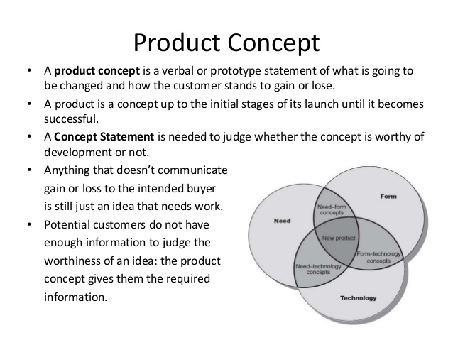
- Research: There are two important things to research at this stage: firstly, demand. If your product solves a problem, are a lot of people looking for a solution to that problem? Can you see a gap that is desperate to be filled? Secondly, are there products out there already that are similar to yours? If so, it doesn’t necessarily mean your idea won’t be a success, but how will you improve on what is already available?
Some source of information that could be utilized during this process includes:
- Books
- Magazines
- Electronical medias
- Printed media
- Computer/ internet
- Research persons
- Manuals
- Working drawings

- Product Development: At this stage, you can begin to develop your product design. There are a number of things you must consider here:
- Have a firm idea of your product’s function
- Think about how strong and long-lasting your product will be
- How reliable is the product?
- What will the manufacturing costs be, and does this allow room for profit without a price that will put buyers off?
- Include dimensions and materials, develop the designs to a high standard and include all vital details.
- Is your product single-use, or long lasting?
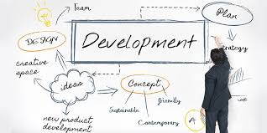
3D modeling: This process uses 3D rendering software such as Autocad or sketchup in order to produce a computer model of your final design. This can help to reveal any potential issues that weren’t evident from the product design itself.
See if there are any faults and issues before it goes to the final manufacturing process.
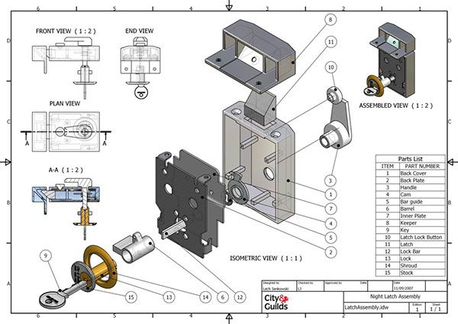

Manufacturing/ Assembling: If you made it through prototype testing without revealing any problems that need to be worked on, it’s time to manufacture your product. There may be some further decisions to make here, such as materials, batch numbers, and the manufacturer itself. Think about what keeps costs low while maintaining the quality you want, so that you can maximise profits.
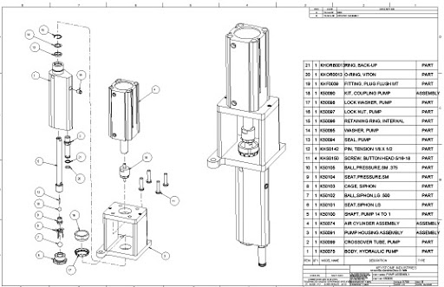

Feedback: Now your product has been manufactured and assembled, you can continue testing it rigorously. There are many ways to do this, from assembling focus groups to asking family and friends, but ensure you take note of feedback and allow free and honest criticism. Allowing for further development to continue improving your product is a sensible move.

Down below you will find a video below illustrating the product design process.

