MANIPULATING ELECTRONIC FILING SYSTEM

Drives is a device on a computer that can be used to store data and documents that is not easily removed. It may be a static storage device or may use removable media. All drives store files and programs used by your computer. For example, when you write a letter in a word processor, the program is loaded from the hard drive. When you save the document, it's saved to the hard drive or other disk or drive.

Each secondary unit attached to a computer is assigned a drive letter by the operating system. Examples of different drives:

- Disc drives: Blu-ray, CD-R, CD-ROM, CD-RW, and DVD.
- Flash drive.
- Hard drive
- Local drive/disk known as (C:) the primary hard drive
- Network drive
- RAM disk
- SSD
- Tape drive
- USB drive
- Virtual drive
Data organization involves fields, records, and files. A document is identified by a dog-eared paper icon with the default program icon:
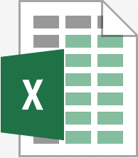
In computing a directory (folder) is a file system cataloging structure which contains references to other computer files, and possibly other directories. A folder can contain other folders called subdirectory. Folders provide a method for organizing files much like a manila file folder contains paper documents in a file cabinet. A folder is identified by a manila folder icon.

A sub-directory (sub-folder) is a directory located inside/within/beneath another directory. The directory that contains the sub-directory is called the parent directory. Sub directories allow you to organize your files in a hierarchical manner.

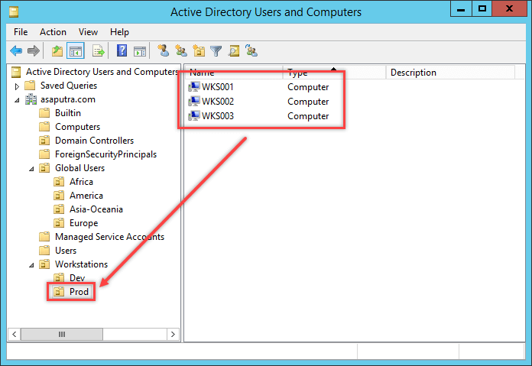
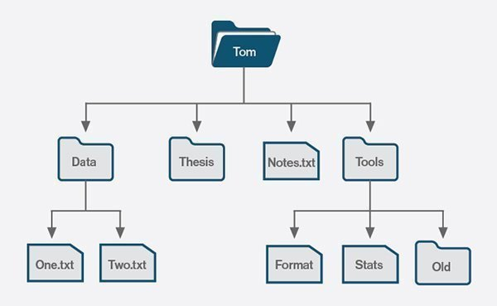
Data hierarchy refers to the systematic organization of data, often in a hierarchical or ‘tree-like” form. In other words Data is organized in layers.
A typical directory structure

A file is a document (text, picture, and video) or a program. A file is the common storage unit in a computer, and all programs and data are "written" into a file and "read" from a file. ... In fact, files that contain text are often called documents. Files are organized into folders and directories. Files are named using characters.

A file name has two parts:

a) name of the file
b) extension
Name is the identity by which a file is stored in the directory or folder.

Extension sometimes called a file suffix or a filename extension, is the character or group of characters after the period that makes up an entire file name. It is automatically inserted by the program. Extensions are important because they tell your computer what icon to use for the file, and what application can open the file or the type of data it contains. For example, the doc extension tells your computer that the file is a Microsoft Word file.

EXTENSION | MEANING
.xls or .xlsx | Excel File (Spreadsheet File). Showing workbook with work sheets.
.doc or .docx | Document File (a document saved in Microsoft Word)
.txt | Text File
.sys | Program System File
.tmp | Temporary File
.jpg | Photograph /Pictures
.gif | Graphics Interchange Format
.exe | Executable File (instructions in binary code that the computer can execute)
.mpg | Movie File
.bmp | Bitmapped Picture a picture whose pixels (picture elements) can be changed by changing the value of its stored binary code.
.mp3 | Music/Sound File
.mdb | Microsoft Access database
.ppt or .pptx | Microsoft Office PowerPoint Presentation file format. Showing slides.
.zip | WinZip file showing compressed files.

Data integrity refers to the validity and accuracy of data. It is ensuring that data is accurately entered into the system and remains accurate while processing and as long as it is needed. There are a number of ways in which data may be compromised:

- human errors - inaccurate data entry;
- software bugs or computer virus;
- hardware malfunctions;
- errors that occur when data is transmitted from one computer to another;
- disk crashes
- deleting or changing data by accident or maliciously; and
- natural disaster such as fire, flood, volcanic eruptions or earthquake.

